Cotswold Spa
School
Prospectus

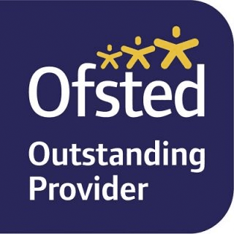
Latest Ofsted Inspection: July 2019

Mission Statement
We aim at the Huntercombe Cotswold Spa School to make each patient’s stay with us a positive experience, where the education provided here is as normal as possible, in what can seem a very abnormal situation. Where possible we aim to help the young people in our care to see the value of education and the benefits it brings to them and society at large. We endeavour to help equip our patients with skills and knowledge to help them lead a happy and contented life.

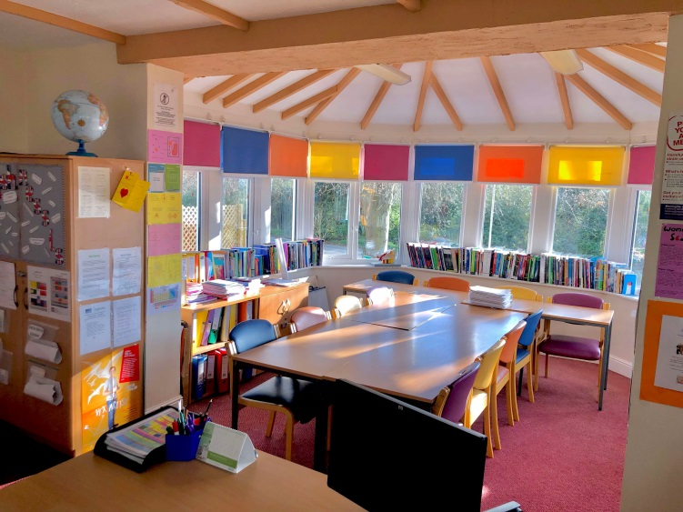

“Pupils are highly positive about their experience at the school. They value the sense of normality that lessons bring as part of their recovery.”
Ofsted report, July 2019

General Information

There is one main school room and three other rooms available if required where we are able to support our patients with their studies whilst they are here at Huntercombe Cotswold Spa.
Our aim is to help our patients engage in their education. We endeavour to facilitate a patient’s studies through strong links with their home schools, to allow them to continue completing work set by their own school, thus preparing them for a return to their home school. Whilst in the school we will take their educational details and help them complete an Individual Learning Plan (ILP). We will then liaise with their school/college in order to help them maintain progress in their education, ready for a return to school/college, when we will help organise and support visits, look at timetables and monitor how they have gone.
We are a registered exam centre and many patients are able to sit their examinations with us as we act as a host centre. We also work closely with schools to ensure patients, if agreed with the medical team, are able to meet examination requirements, such as practical assessments.
We are also able to offer Entry Level exams throughout the year for those who may require them.
We are based within the hospital and liaise closely at every stage with the medical team. The patients are free to leave sessions for therapy, other therapeutic meetings and medical checks. We attend daily handover meetings with medical staff and are part of the hospital’s management structure. We contribute weekly to care notes and our reports are used within patient review meetings.
Our role is to link in with the medical team, whenever necessary and appropriate, in order to facilitate a patient’s recovery.
The school room is light and airy with brightly coloured furniture, overlooking the garden at the front.
The schoolroom is equipped with 3 computers, 2 tablets and a white board. We also have a range of mathematical and science equipment, literary texts, textbooks, drawing and art materials. We are able to order resources and textbooks depending on each student’s individual needs.

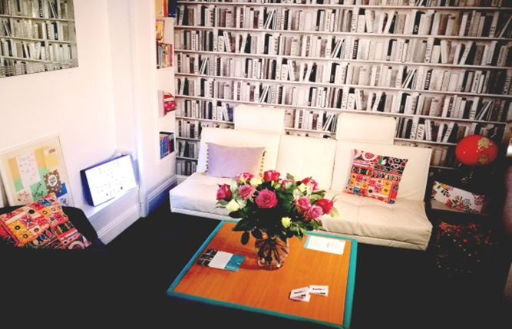
“The school is led and managed exceptionally well. The proprietor and head of education ensure that a focus on learning is paramount while pupils are in the school. The Huntercombe Hospital group holds them closely to account for that education being of high quality.”
Ofsted report, July 2019

Admission

Admission to the school is only possible through a hospital admission implemented by our medical team led by:
Acting Consultant Psychiatrist: Dr Diane Cook
Disability Access
As part of Huntercombe, at Cotswold Spa School we are committed to increasing our disability access.
We work with the patients on an individual basis and aim to ensure their individual needs and requirements are catered for.
For anyone with mobility concerns, the school room is situated on the ground floor of the hospital and it is already accessible to wheelchairs with a ramp at the front entrance and a lift to all floors.
For all other issues we will work with the patients closely to ensure their individual needs are met, as far as we can, to make their time in the school as rewarding and worthwhile an experience as possible.

Special Education Needs/Education, Health and Care Needs
Pupils are assessed on admission and any SEN/EHC aspects are recorded. As a SEN school we are primarily concerned with our pupils’ social, emotional and mental health. Our role is to respond to the behavioural and learning needs of all our patients. As a staff we are committed to their reintegration, wherever possible, back into their mainstream school.
All our patients will have SEN requirements; they will therefore be monitored closely and supported in all areas of the curriculum, in accordance with their individual needs. From admission we will liaise and consult with the medical staff in the hospital and teachers at their home schools, to ensure their time in education aids their recovery and that we have responded to their behavioural and learning needs. If required, we will also consult with outside agencies.
For example, those with dyslexia will be allowed extra time in their examinations, if this has been registered with the exam board.
We also allow patients to work at their own pace and try and engage them in the educational process through motivation and interest; this can sometimes mean their periods of concentration can be quite short and we work to extend this in preparation for their return to school.
We are committed through our teaching and interaction with our pupils to remove any barriers to learning. We hope this will facilitate their progress and development in accordance with their needs.

Diversity and Britishness
We aim to provide a balanced and unbiased viewpoint over a range of subjects in PSHE and citizenship and promote the sense of belonging, no matter what a patient’s religious belief, ethnicity, sexuality, gender identity or mental ability.
We promote a sense of Britishness, belonging to the community of people who live, work and play in this country. Our curriculum encourages students to question their own points of view and those expressed in the media and other sources in order to promote an ethos of tolerance, thoughtfulness, inclusivity and curiosity. Our aim is for patients to have a strong sense of what it means to be both British and global citizens.

-
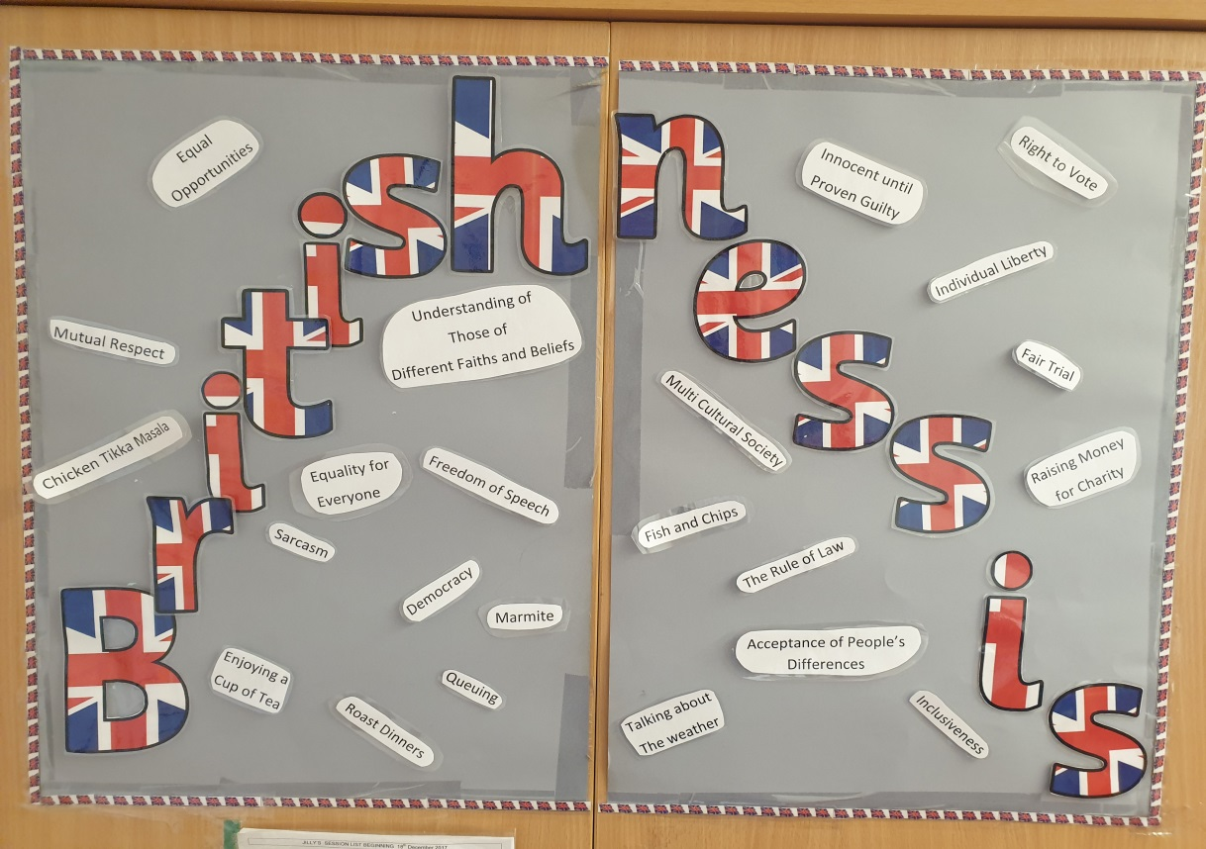
The Staff
Governing Body
Chair: Registered Hospital Manager: Pauline Wilson
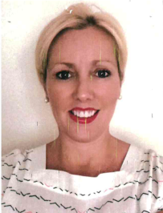
Pauline.wilson@huntercombe.com
School governors:
Claire Blakemore (Head of HH School Stafford) claire.blakemore@huntercombe.com
John Evans (Quality Partner) john.evans@huntercombe.com
Adrian Harrison (Commercial Projects Lead) adrian.harrison@huntercombe.com
Angela Hudgell (Head of HH School Maidenhead) angela.hudgell@huntercombe.com
Catherine Woodsmith (Head Teacher) catherine.woodsmith@huntercombe.com

Head of Education: Catherine Woodsmith
Examinations Officer and Safeguarding Lead
MA (Oxon.) and PGCE
(Full-time, modern foreign languages, maths, & performing arts)
Email: catherine.woodsmith@huntercombe.com

Teachers

David Griffin BSc and PGCE
(Part-time, Tue & Fri - humanities & PSHE)

Email: david.griffin@huntercombe.com

Claire Watson BA and L3 Teaching & Training
(Part-time, Thu - art)

Email: claire.watson@huntercombe.com

Jenny Curry BEd
(Part-time, Thu - English)

Email: jenny.curry@huntercombe.com

Natalie Johnson BSc and MA PGCE
(Part-time, Mon & Wed – science & maths)

Email: natalie.johnson@huntercombe.com

Or phone: 01386 853523

Curriculum
“Pupils do, indeed, keep up with their classmates back at school. The high-quality teaching they receive often helps pupils to make progress beyond that anticipated by their ‘home’ school.”
Ofsted Report, July 2019

KS3 and 4
All subjects are offered to our patients, primarily core curriculum subjects of English, mathematics and science. We facilitate a patient’s studies through strong links with home schools, to allow pupils to continue completing work set by their own school, maintaining their links to aid integration on recovery.
With subject specialists in:
English Language English Literature
Modern Foreign Languages Mathematics
Science History Geography Religious Studies Art
With support and guidance in:
Music Latin Physical Education (theory)
Dance (theory) Theatre Studies Business Studies ICT
PSHE, citizenship and enrichment
PSHE and citizenship are taught weekly to keep students engaged and informed in important real-world events and life skills. Throughout the courses they learn about various aspects of health, relationships, society, law, and what it means to be British. The school curricula for these subjects are available on request.
In addition to these vital subjects, students participate in timetabled finance, careers, current affairs and performing arts sessions to enrich their learning and skills beyond their academic subjects.
A Level
Sixth Form patients are able to continue their studies, across a wide range of subjects, working independently in a calm environment with access to the internet should any questions arise that cannot be covered by our teaching staff. We facilitate this by strong links to home school.
With subject specialists in:
English Language and Literature
Sciences Modern Foreign Languages Psychology
History Geography Religious Studies Art
With guidance and support:
All other areas of the curriculum can be covered.
Examinations
We are a registered examination centre so patients can sit public examinations from GCSEs to A levels. These examinations are conducted according to JCQ guidelines in the calm environment of the hospital. This is usually done through a transferred candidate arrangement with the patient’s home school or college. We are able to enter patients as independent candidates and have previously allowed ex-patients to sit their exams if not attending a school or college in the community, in order to see their studies through to a successful conclusion.
Careers
Students follow a careers curriculum and impartial careers advice is available with support and guidance on how to find out any information relevant to their choice. This may be talking about career pathways via school, college, university or apprenticeship. We can also offer advice on personal statements and CVs. Due to the nature of students’ illness, it is not practicable to carry out work experience during their admission but we are committed to providing opportunities to visit different work places or to discuss careers with external speakers from various fields.
Reporting
Each patient has an ILP (Individual Learning Plan). This is discussed and put together with the patient, so they have ownership of the plan and it is reviewed once a month to link in with the patient’s review. At this point an in-depth report is written for the review, which keeps parents and carers up to date with how the patients are getting on academically. This is in addition to weekly updates sent to parents and home-school teachers updating them on each student’s progress and wellbeing.
We keep in regular contact with the patient’s school to ask for work and also to monitor how school visits go as we progress towards discharge. We will also return work to schools or colleges for assessment if needed. At discharge we write a detailed discharge report which will inform a patient’s home school of the learning which has been achieved.
Finally we like to talk to you the parents and carers whenever we can so that we can work together to ensure each patient gets the best out of their stay at The Huntercombe Hospital, Cotswold Spa.

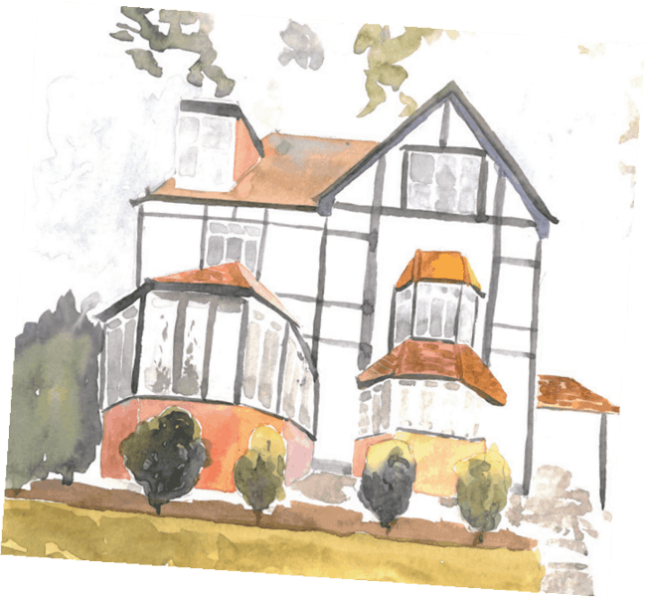

I find it easy to talk to staff and they set a good example
My teachers demonstrate passion & knowledge of their subject
I have access to appropriate teaching resources such as textbooks and IT
I am actively engaged in my learning
School Feedback
“It's relaxed but I still get the work done and it's a safe environment that provides great distraction. The teachers are all really nice and supportive, they understand as well.”
“Comfortable and happy environment to work in. I feel like I work really well and so much better in the classroom as it enables me to concentrate and achieve.”
A
“Teachers are friendly and considerate they go out of their way to support students and create a pleasant environment”
What patients say:
What parents say:
“[my child] has covered more and learnt more in one morning than she has at school in months!”
“I think you should be the cornerstone for other inpatient units”
“Thank you for your communication and hard work...which has enabled [my child] to settle back in so well.”
“Bright, welcoming, informative environment. Lots of GCSE resources. Dedicated, supportive staff”
In our Spring 2019 survey students unanimously rated their learning experience as 5 out 5
and agreed 100% with the following statements:
I am treated fairly and with respect
I enjoy learning at school
I am encouraged to take responsibility for my own work in class
I am listened to
My learning plan is discussed with me and we discuss targets
I am given coursework, assessments and homework when relevant
I get verbal or written feedback on how well I am working, and advice on how to improve
My teachers always try to spend time with everyone in the group
I feel safe at school
If I am having a bad day my teacher will notice and change their approach
My teachers are aware of my individual needs
Policies Available
The following policies are available on request from C Woodsmith:
Child Protection & Safeguarding Policy
Curriculum Policy
Behaviour Policy
Bullying and Cyber Bullying Policy
(Internet) Acceptable Use Policy
Complaints Procedure & Policy
If you have any questions, complaints or concerns, please contact Cat.
On: 01386 853523
Or email:hhcotswoldspaschool@huntercombe.com

Updated June 2020

