cid:image001.png@01D0618A.760E8AB0

**Huntercombe Hospital School Maidenhead**

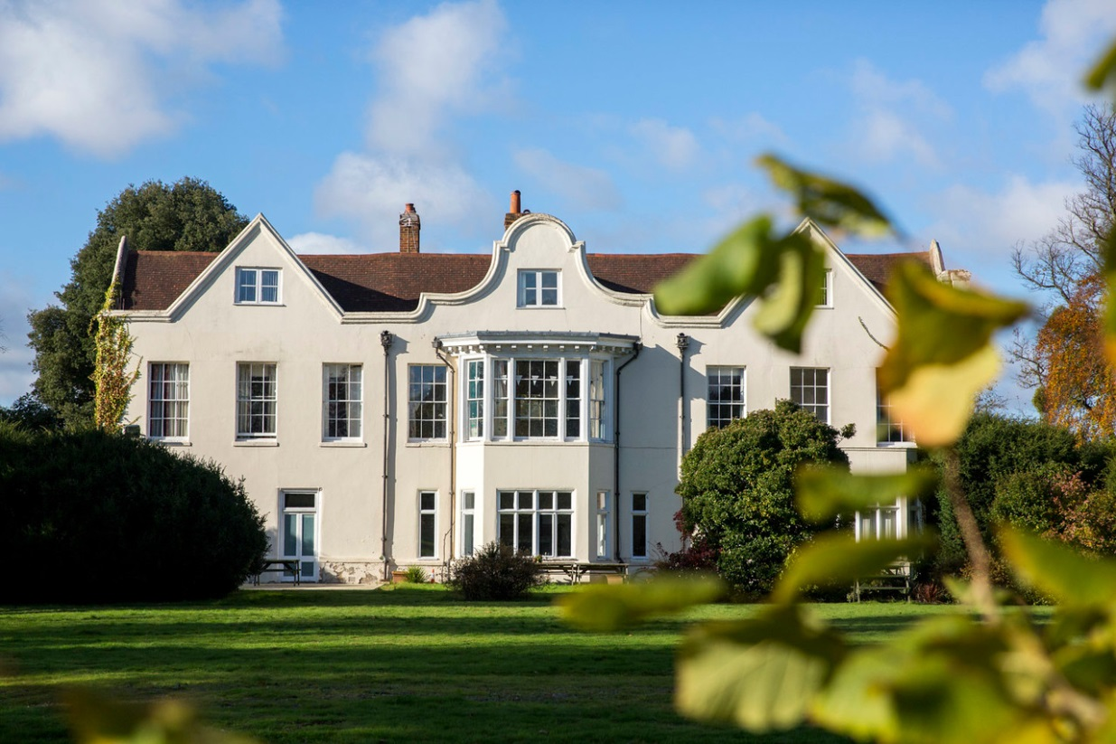

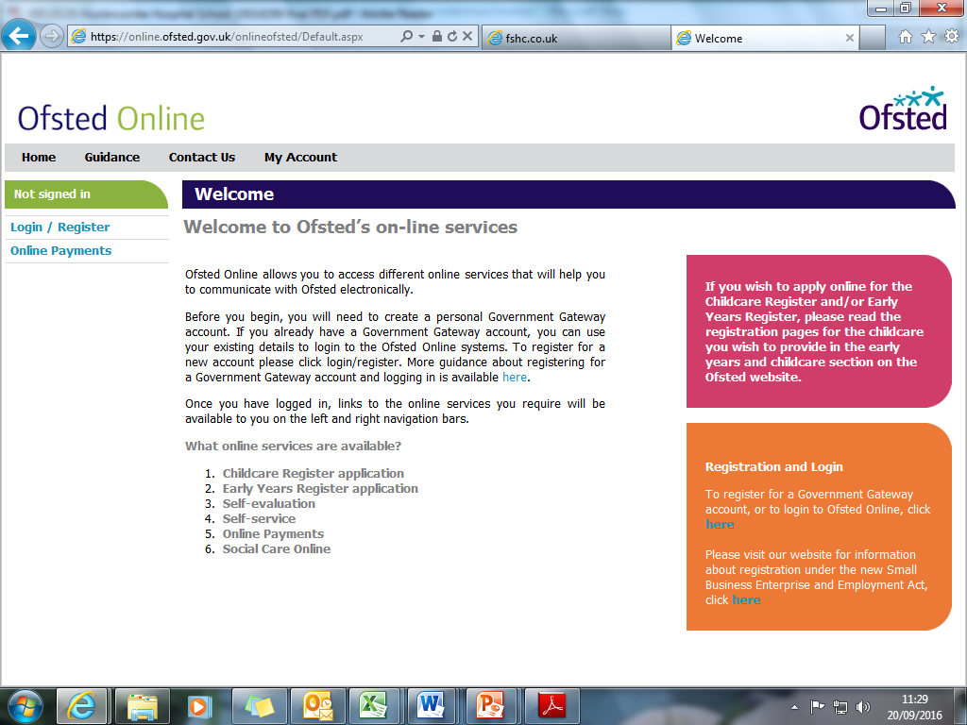

say this is a **Good** school



**Huntercombe Hospital School Maidenhead**

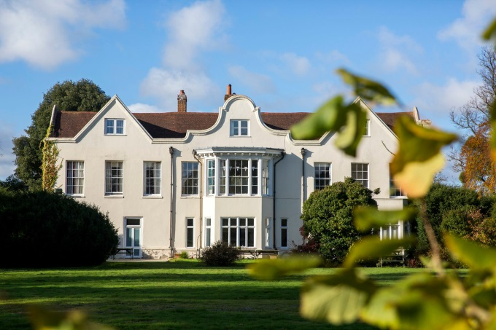

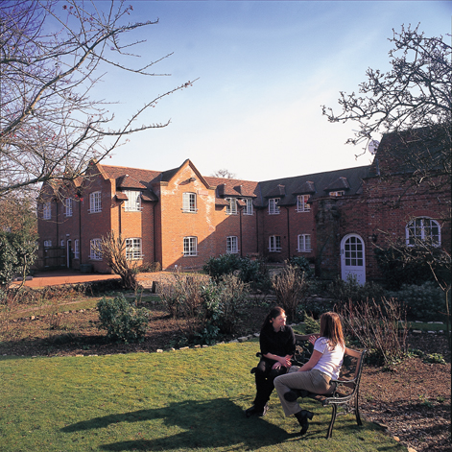

**Mission Statement**

We aim at Huntercombe Hospital School Maidenhead to make each patients stay with us a positive experience, we aim to minimise, as far as possible, disruption to normal schooling during a young person’s stay in hospital, by continuing education as normally as the incapacity allows. Where possible we aim to help the young people in our care see the value of education, we promote a positive and structured educational experience within a learning space where young people can feel safe, respected and valued. This will enable them to learn and develop within boundaries that are healthy for them.

# Contact Information:

Huntercombe Hospital School Maidenhead

Huntercombe Lane South,

Taplow,

Maidenhead,

Berks

SL6 0PQ

[www.huntercombe.com](http://www.huntercombe.com)

**E:** hhmaidenheadschool@huntercombe.com

**T:** 01628 607435

Nick Rose **-** Head of Education CAMHS **T:** 01628 607455

**Proprietors address:**

The Huntercombe Group  
Oaks Lodge, Fordham Road  
Newmarket  
CB8 7XN  
Tel: [01638 606 300](tel:01638%20606%20300)

Angela Hudgell **-** Education Manager

Fay Fisher **-** DeputyEducation Manager

**Designated Safeguarding Lead for Education** **-** Angela Hudgell

**Designated Safeguarding Deputy for Education** **-** Fay Fisher

**DfE number:** 868/6023

**URN:** 142325



say this is a **Good** school

* Teachers are dedicated to improving students’ life-chances. They have excellent subject knowledge, plan lessons carefully with students’ individual abilities in mind and are responsive to their changing needs.
* Students are safe in the school. Their welfare, physical health and emotional well-being are completely central to everyone’s work.
* There is a strong focus on promoting students’ spiritual, social, moral and cultural development. Regular events and projects help students to recover and contemplate a positive future.

**Ofsted** report available from:

<https://reports.ofsted.gov.uk/inspection-reports/find-inspection-report/provider/ELS/142325>

# Our School

Huntercombe Hospital School Maidenhead caters for young people aged 12-18yrs in inpatient Child and Adolescent Mental Health Services (Tier 4 CAMHs). We are committed to and passionate about the learning and progress of our students. Staff have high aspirations for our patients and we aim to provide a high quality, relevant and balanced education for all our students that focuses on individual, personal and academic achievement while they are recieving hospital treatment.

Students are taught in small groups, there is a motivational and positive atmosphere in the school rooms, which provide a familiar educational environment within the hospital.

Students are taught in key stage groups for all subjects apart from music and P.E. All students have an individual Learning Plan which is reviewed every six weeks or before if needed.

Through strong partnerships with home schools and collaboration with the multidisciplinary team in the hospital the school offers a caring and friendly learning environment in which students can maintain progress and regain confidence.

Angela Hudgell

Education Manager

Please note – “Parent” includes guardian and any person who is liable to maintain or has parental responsibilities in relation to, or has care of a child or young person.

Please note that whilst all information within this booklet is correct at the time of printing, it is possible that some items may change during the course of the year.

**Safeguarding**

“All children and young people have the right to be cared for and protected from harm and to grow up in a safe environment in which their rights and needs are respected. The welfare of children is paramount”.

Protecting children and young people is a priority for Huntercombe Hospital School Maidenhead. It is everyone’s job to ensure that children are kept safe.

All of our teaching staff recieve safeguarding training and professional updates, and are familiar with the safeguarding policy of the school. Due to the nature of our student group, many of our young people are already involved in safeguarding procedures such as Case Conferences. As such, all safeguarding issues and queries are passed to the Designated Member of Staff for Huntercombe Hospital School Maidenhead, and this is immediately shared with the Safeguarding Leads for the Huntercombe Hospital Maidenhead, following the Hospital's Safeguarding Policy.

All staff working within the School and the Hospital are subject to the DBS checks. Any guest speakers we include in the curriculum or contractors who may visit the site to carry out maintenance are escorted by DBS checked staff at all times. The Education Manager and the Head of Education for CAMHs have attended training on Safer Recruitment.

**Designated Safeguarding Lead for Education** **-** Angela Hudgell

**Designated Safeguarding Deputy for Education** **-** Fay Fisher

**Admission and Attendance**

We provide education to students aged 12-18 from the first day of admission to hospital as far as their condition allows. Provided they are in a position to engage they will then be expected to attend all lessons unless they have a hospital appointment.

All of our students remain on the roll of their own Local Authority. Each student is assigned a Link Teacher who liaises with the Home School in order to establish an educational and social history, discuss a suitable learning plan, and co-ordinate a transition out of services and back to school.

Due to the nature of our student body within the hospital, we are flexible around attendance to accomodate physical and therapeutic treatments. Hospital Appointments are made in laision with the school, and the balance between attendance and appointments is reviewed at the weekly Patient Review Meeting (PRM) to ensure the needs of the young person are met.

Non attendance to school is also discussed at the Patient Review Meeting (PRM) and informs strategies for the Link Teacher to discuss with the young person to address this. If necessary a medical decision to sign the young person off school for a period will be made at the Patient Review Meeting.

**Communicable/Infectious Diseases**

When students are off school because of sickness or diarrhoea, they should remain on the ward and not return to school for 48 hours after symptoms have passed. Students must be kept off school for a period of time where they have an infectious or contagious disease. These include common ailments such as impetigo, conjunctivitis, chicken pox etc.

**Behaviour and Expectations**

Positive Behaviour Management is a vital component in helping Huntercombe Hospital School Maidenhead to achieve its aims and values. Our Behaviour Management Policy also provides our students with the boundaries and rules that they need in order to fulfil their potential and contribute to the wellbeing of others. The general aim of the school is to provide an atmosphere of mutual respect and collective responsibility.

We aim to provide a safe and pleasant environment for all the community, where individuals are treated with respect and consideration. To make this possible students and staff are asked to follow our expectations:

* Staff and patients’/students’ should conduct themselves in a manner as not to disrupt or hinder the activities within the class room. This code of conduct should extend to all school based activities, including school trips.
* Staff and students will treat each other with respect and sensitivity.
* Students should know and be aware that the teaching staff are at all times are acting in regard for their welfare and safety within the school environment.
* Students are asked to be considerate and understanding of peer’s difficulties within the hospital environment.
* Any behaviour’s creating difficulties in delivering education or for education to take place, should always be dealt with in a sensitive manner.
* Some behaviours in a psychiatric setting are going to be tolerated, more so than in a mainstream setting, medication for example has an effect on patients interaction with peers and staff.
* There is no punishment or disciplinary procedures in this school for antisocial and disruptive behaviour, other than the withdrawal of the patient from the classroom.

**Role of Home School/College**

Our Link Teachers work closely with the Home School of each of our young people. The students remain on the register of their own school, and where possible, the learning plan developed will allow the young person to follow the subjects and topics they would have been covering at school.

These positive links support the student to regain their confidence in their own learning, which is often eroded when they have missed school and been admitted to hospital. It helps to prepare them to return to school, and allows them to know that the work they are doing is targetted and meaningful.

Every six weeks our patients have a Clinicial Progress Review, an education report is issued to each of these meetings. In addition to this formal feedback the Link teachers are in frequent phone and email communication with home schools.

When the young person is working towards discharge, the young person, their parents and the home school will discuss strategies to work towards a successful transition. Often this will involve home leave from hospital. At this time the student might attend their own school for some of the week and then spend the rest of the week attending Huntercombe Hospital School.

# Parents as Partners

At Huntercombe Hospital School Maidenhead we value the role of parents, and aim to keep them involved with their child's progress, and in decisons about their education and strategies that will help them make a successful transition back to school.

Individual meetings can be arranged with the Link Teacher when necessary.

Link Teachers will keep parents/carers informed of their child's progress with their education.

We have a variety of community events such as the Christmas Sing-a-long Concert, Christmas fair & Summer Fete. Parents are invited to be part of this.

For parents/carers that have a child on Kennet unit there is a parent/carer forum group, they meet monthly with professionals that are involved in the patients care. Education is represented and this gives parents/carers an opportunity to see how our education is structured and raise any concerns they may have.

**School Policies and Complaints**

All our school policies are available to view upon request. Please contact the Education Manager if you would like a copy.

We are happy to discuss any aspect of your child’s education in hospital with you at any time. Please contact the school office on 01628 607435

If you have more serious concerns or would like to make a complaint please contact the Education Manager on 01628 667881 ex 235

**Learning and Teaching**

Our teaching methods recognise and reflect that each young person is an individual with their own aspirations, aptitudes, and reasons for being in hospital. We aim to develop each young person to their full potential. We use a variety of teaching methods to cater for a range of learning styles. We believe in active learning for all students at all stages with children fully engaged in thinking. In promoting active learning, we recognise the importance of ensuring that learning experiences are stimulating and challenging.

We aim is to make learning relevant and meaningful and to promote enthusiasm for life-long learning. Not all students do the same work at the same time; within any class the teacher will regularly allocate tasks that are set at different levels of difficulty. The aim is to challenge all students but at the same time give them work that is within their capabilities so that each young person experiences success.

On transition back from our service back to their own school or to other routes, the aim is that each young person will have developed at their own pace, with an awareness of their own potential.

Through the use of Individual Learning Plans, 'How did I do“, and Weekly Planning Logs, the students are involved in setting their own targets and planning next steps in learning. For further information on specific aspects of learning, please contact your child’s Link Teacher in the first instance.

Through our holistic approach providing for the emotional, physical and social needs of all, we ensure an atmosphere of trust and respect of everyone in a safe and inclusive environment.

**Assessment and Reporting**

Teachers carry out continuous assessment as part of their daily practice to ensure that learning activities are meeting the needs of their students and extending and developing learning. Assessment information is used to track students’ progress, inform planning, direct future learning and teaching activities and for reporting purposes. The overall purpose of assessment is to support learning.

Huntercombe Hospital School Maidenhead uses a variety of formative assessment techniques in teaching the children how they can improve upon their current standards of work. This applies to all students, regardless of ability and ensures that opportunities to progress and achieve are fair and inclusive.

Formative Assessment includes:

• Sharing learning intentions, success criteria, ideas and expectations

• Promoting creative thinking skills by using quality questioning techniques

• Giving constructive feedback to students which is focused on improvement

• Assessing what children Make, Say, Write and Do and planning teaching activities to support future learning

Link teachers record students Mental Functioning in Education weekly. Students will also have an education report written for their CPAs.

National advice outlines that for learners to demonstrate that their progress is secure and that they have achieved a level, they will need opportunities to show that they:

• Have achieved a breadth of learning across the experiences and outcomes for an aspect of the curriculum

• Can respond to the level of challenge set out in the experiences and outcomes and are moving forward to more challenging learning in some aspects

• Can apply what they have learned in new and unfamiliar situations

Students are also encouraged to self and peer assess, and recognise their own strengths and learning needs. Teachers set realistically challenging targets for their students, helping to ensure that the pace of children’s learning is appropriate. More formal assessments are also carried out. These are usually provided by the student's Home School, for the purposes of assessing the young person in line with their peer group at home.

Students keep a weekly planning log and are encouraged to reflect on their learning that lesson is developing, consolidating or secure.

If appropriate arrangements are made with the exam board for GCSE, A’level exams to be taken here at the hospital.

**Curriculum**

Huntercombe Hospital School Maidenhead offers a broad and balanced curriculum aimed at creating an educational experience that prepares students to return to their home school as a confident individual, a responsible citizen, a contributer and an independent learner.

Our students represent a very wide range of abilities and backgrounds, coming from Schools all over England, and as such have a variety of exam boards and learning expectations from their own schools. In response, our curriculum provides a number of pathways that young people can follow, and we maintain active Schemes of Work for the National Curriculum.

A strong emphasis on a value added approach means that our young people can focus on recovery without pressure. Many of our young people have been long-term school refusers or sporadic attenders for a variety of reasons prior to admission, and our school provides a safe and effective route back into education. Many re-engage and have either acheived exam results while under our care or made a successful transition back to school in their own local authority.

At Keystage 3 students follow our timetable and when appropiate complete their own school work under the supervision of the subject teacher.

At Key Stage 4 our specialist teachers will support students work through liaison with the students’ own school as well as delivering lessons across the curriculm. The Key Stage 4 courses, especially GCSE, allow for progression and reward of attainment, which can be incredibly important to a young person experiencing poor mental health.

Our teaching styles and approaches to learning are about allowing our students to experience joy, friendship, effective contribution and responsibility.

Students who are disengaged with school work with their link teacher to find a way forward, this maybe with a reduced timetable at first. Functional skills in English and maths are offered at Entry Level 1, 2 & 3 with progression to Level 1 & 2. AQA unit awards are also used to re-engage and boost confidence.

KS5 work more independantly with guidance from our specialist teachers, students follow work set from their college/school and have access to their VLE. For students who are not enrolled with a college/school we suggest joining Y11 Maths and English lessons if they have not achieved at least a grade 4 at GCSE or subjects they didn‘t study in KS4. For those this doesn’t apply to we will look for other acredicated courses that they are interested in.

**Literacy across the curriculum:**

Whatever the subject area, your child will be:

* Engaged in talking together to deepen their learning and thinking.
* Writing clear explanations
* Communicating information or opinions
* Taking account of others’ points of view or alternative solutions and responding in ways appropriate to role and demonstrating the ability to contribute, reflect, clarify and adapt thinking.

For students on our PICUs the lessons are planned for the whole group which ranges from KS3 to KS5, differentiated work is provided. Students follow an ILP and some will have and indivual timetable and not attend all sessions. When appropiate a timetable will be put together with the link teacher and MDT for the student to attend some of the Manor school timetable.

**PSHE** - Principles of Personal, Social, Health and Citizenship, SMSC development are incorporated into all of our teaching strategies and combined with learning objectives across the subject areas.

Citizenship education helps to provide students with knowledge, skills and understanding to prepare them to play a full and active part in society. In particular, citizenship education should foster students’ keen awareness and understanding of democracy, government and how laws are made and upheld. Teaching should equip students with the skills and knowledge to explore political and social issues critically, to weigh evidence, debate and make reasoned arguments. It should also prepare students to take their place in society as responsible citizens, manage their money well and make sound financial decisions.

* acquire a sound knowledge and understanding of how the United Kingdom is governed, its political system and how citizens participate actively in its democratic systems of government
* develop a sound knowledge and understanding of the role of law and the justice system in our society and how laws are shaped and enforced
* develop an interest in, and commitment to, participation in volunteering as well as other forms of responsible activity, that they will take with them into adulthood
* are equipped with the skills to think critically and debate political questions, to enable them to manage their money on a day-to-day basis, and plan for future financial needs
* celebrating the diversity of our own community and our place in the wider world
* promoting equality and fairness while developing informed and ethical views
* developing an understanding of how we can all take responsibility for protecting and conserving our planet

**LGBT**

We pride ourselves on being an inclusive school who supports the needs of distinct groups of students, such as lesbian, gay, bisexual and trans students, and those with lesbian, gay, bisexual and trans parents/carers. HBT, homophobic, biphobic and transphobic bullying will always be dealt with.

As a school we educate pupils to understand the rights of all people to live freely within their sexual orientation or gender identity without discrimination and prepare our students to live in modern Britain. LGBT history month in February will be included in the PSHE curriculum, using resources from Amnesty International and Stonewall. This is in line with the Equality Act 2010 and incorporates the `protected characteristics’. Our school is now a Stonewall School Champion and is working towards the Bronze award.

**Equality**

In our school equality is a key principle for treating all people the same irrespective of their gender, ethnicity, disability, religious beliefs/faith tradition, sexual orientation, age or any other of the protected characteristics (Equality Act 2010). We have a high expectation of all students regardless of age, gender, ethnicity, ability, social background and sexual orientation to secure the best possible outcomes

**Careers program**

The DfE released an updated statutory guidance document in January 2018, including a number of new requirements for school careers programmes, most of which are to be met by the end of 2020. Many of the requirements are already met at Huntercombe Maidenhead, but we will be working towards those that are not.

The careers provision that is offered in the Huntercombe Hospital School Maidenhead is offered to all of the students. The main aim is for the students to ‘know themselves and how their strengths, weaknesses, learn about different careers and opportunities and obtain individual guidance’. We aim to comply with statutory requirements in the Gatsby Guide, which states eight benchmarks:

1. A stable careers programme   
2. Learning from career and labour market information   
3. Addressing the needs of each student   
4. Linking curriculum learning to careers   
5. Encounters with employers and employees   
6. Experience of the workplace   
7. Encounters with further and higher education   
8. Personal Guidance

At Huntercombe School Maidenhead we are committed to providing all our students in years 7 to 13 with a comprehensive program of careers education, information, advice and guidance we deliver the careers provision through the curriculum. Careers lessons in PSHE (KS3, KS4 & KS5) and Tutorials (KS3, KS4 & KS5) linking into their own career pathways. KS4 & 5 also have an enterprise and careers session.

During National Careers week we have various Careers presentations. At other key times (for example, every half term and after the GCSE exam period we will run careers sessions).

In addition to this we have links with Elevate and Grow your Own our LA careers program, who will come into our school and provide support and guidance. Students also have the oppurtunity to attend British Airways careers events and local careers events in the area.

Work experience is dependant on whether the MDT feel it is safe to complete and in the best interests of the student at that time. Depending on when a student is with us they may have completed this in their mainstream school/college.

**Our careers lead is Fay Fisher**

**Spiritual, moral, social and cultural development (SMSC) and British values**

* democracy
* the rule of law
* individual liberty and mutual respect
* tolerance of those with different faiths and beliefs

This is promoted in our Citizenship, R.S & PSHE curriculum and is also evident in other subject areas and in our school rooms.

**Relationship & Sex Education (RSE)**

The Children and Social Work Act 2017 require: All secondary schools in England to teach age-appropriate ‘relationships and sex education’ The Department for Education (DFE) requires Sex Education to be provided as part of the National Curriculum and it is taught with due regard to moral considerations and an emphasis on the value and importance of family life and keeping safe.

Relationships and Sex education (RSE) is lifelong learning about healthy relationships, sex, sexuality, emotions, and sexual health. The objective of RSE is to help support young people through their physical, emotional and moral development. We recognise the importance of RSE in preparing young people to live safe, fulfilled and healthy lives. RSE is taught as part of our PSHE program, some parts of sex education are taught in science.

We believe that effective, age-appropriate education about relationships and sex can: Foster positive attitudes and values of love and respect; promote spiritual, moral, social and cultural development. If young people can make their transition into adulthood with good information and the confidence and knowledge to understand what is happening to them, they will hopefully grow into confident and healthy adults able to make positive choices. We believe parents and carers have a crucial role to play in their children’s learning about healthy relationships and sex education. We intend that the school’s RSE programme complements and supports their role.

**Sixth Form Provision**

At Huntercombe Hospital Maidenhead we encourage our sixth form to have a positive attitude to learning and provide good role models for the younger students.

We support our students with their A Level and further education qualifications at school or college. This involves detailed communication with the institute offering the qualification, and we support the student to take responsibility for their own learning and provide some 1-2-1 sessions.

Our sixth formers have more responsibilty for their own learning than younger students. Many use our IT facilities to login to their own college or school website to continue distant learning.

All of our sixth formers can attend taught lessons linked to their ILP, often giving them the opportunity to be in a subject they did not study at KS4. If they have not achieved Maths and English GCSE at grade 4 they are encouraged to join the sessions so they can work towards sitting the GCSE.

For those in the 6th form that are not currently enroled with college/school our Deputy will work with their Link Teacher and devise a personalised program of study. We offer short courses from ASDAN, Future Learn, Open Learn, Functional Skills and BSBK skills courses as well as sessions on careers and future education placements.

Many of our sixth formers have successfully completed their exams with us and gone on to university or other further education establishments.

**Structure of the Day**

The School forms a large part of the group program within the hospital. Kennet and Tamar follow the same education timetable and have other unit specific groups. Patients on Severn and Thames are able to attend some sessions in the Manor school when their risks and it is not detrriemtal to their mental health has been discussed at the PRM.

**Kennet & Tamar Timetable**

|  |  |  |  |  |  |  |  |  |  |  |
| --- | --- | --- | --- | --- | --- | --- | --- | --- | --- | --- |
| Classrooms | | **ART/SCIENCE** | | **MAIN** | | | | **AVON** | | |
| MONDAY | 9.30 |  | | **TUTORIAL - Kennet** | | | | **TUTORIAL - Tamar** | | |
| 10.50 | **KS3**  **Supported Study** | | **MATHS Y11** | | | | **ENGLISH Y10** | | |
| 11.40 | **MATHS Y10** | | | | **ENGLISH Y11** | | |
| 2.00 – 3.30 | **6TH FORM**  **B.S/MFL** | | **R.S/CITZ**  **Y10/11** | | | | **KS3 ENGLISH** | **A LEVEL**  **ENGLISH Lit**  **(6TH FORM)** | |
| TUESDAY | 9.30 | **ART KS4** | | **HISTORY KS4**  **Supported Study** | | | | **SCIENCE KS3** | **6TH FORM** | |
| 10.50 | **Art Y11** | | **English 1-2-1**  **Supported Study** | | | | **SCIENCE Y10** | | |
| 11.40 | **Art Y10** | | **HISTORY KS3** | | | | **SCIENCE Y11** | | |
| 2.00 – 3.30 | **Mixed Media** | | **MFL**  **Supported study** | | | | **6th Form**  **Biology** | | **3pm**  **1-2-1** |
| WEDNESDAY | 9.30 | **ART KS3** | | **BSBK**  **Study** | | | | **QUIET ROOM**  **Supported Study** | | |
| 10.50 | **6TH FORM** | **Vocational Art (ILP)** | **KS4 Computer science Enterprise/career skills** | | | | **GEOG**  **KS3** | | |
| 11.40 | **ICT KS3** | | | | **GEOG**  **KS4** | | |
| 2.00 – 3.30 | **KS3 maths** | **6th form Maths** | **Supported Study**  **A Level Geog** | | **R.S KS3** | | **Supported Study** | | |
| THURSDAY | 9.30 | **SCIENCE KS3** | | **MATHS Y10** | | | | **QUIET ROOM**  **6th Form**  **Supported Study** | **Link work/ILPs** | |
| 10.50 | **SCIENCE Y11** | | **MATHS KS3** | | | | **ENGLISH Y10** | | |
| 11.40 | **SCIENCE Y10** | | **MATHS Y11** | | | | **ENGLISH KS3** | | |
| 2.00 – 3.30 | **Making Choices**  **6th form 2.30** | | **Supported Study** | **Supported Study**  **1-2-1 Maths** | | | **ENGLISH Y11** | | |
| FRIDAY | 9.30 | **PSHE KS3** | | **PSHE KS4/5** | | | **1-2-1** |  | | |
| 10.50 | **1-2-1 Maths** | | **QUIET ROOM/ Study**  **Careers/ 6th Form** | | | | **MUSIC** | | |
| 2.00- 3.30 | **MUSIC 1-2-1 SESSIONS 2-4PM**  **(ALL UNITS)** | | **SMSC – CREATIVE STUDIES** | | | | **P.E – Astro court** | | |

**Severn & Thames Unit School timetable**

Individual sessions are also available and students can attend the school in the manor when this becomes appropiate. The unit link teacher opens the school room for student access when needed. Our Youth Engagement Practioners will also work with our students who are struggling to engage in education sessions under the guidance of the teaching staff with vocational activities.

|  |  |  |  |
| --- | --- | --- | --- |
|  |  |  |  |
| **Monday** | **TUTORIAL –**  **Link teacher session** | **R.S/Citizenship** | **MATHS** |
| **Tuesday** | **GEOGRAPHY** | **PSHE** | **ENGLISH** |
| **Wednesday** | **Enterprise & career skills /ICT** | **1-2-1**  **Supported Study** | **ART** |
| **Thursday** | **HISTORY** | **MFL** | **SCIENCE** |
| **Friday** | **Music** | **SMSC** | **Sport (Astro court) Literacy (classroom)** |

**Exams and Certificates**

The Huntercombe Hospital School Maidenhead is a registered examination centre which enables patients to sit their exams during their stay with us. If your child is in hospital during the summer examination period for GCSE or A level examinations, the examinations officer at the hospital will contact the school to arrange a transfer candidate agreement. Your child will still be entered for their examinations by the home school but the examination paper will be sent directly to the hospital prior to the start of the exams. The results will be sent to the home school and be available in August following the exams period.

We offer the AQA PSE course as part of Independent learning, students can have their work moderated when they have completed modules.

4 units = Award

7 units = Certificate - at level 1 & 2 this is equivilent to a GCSE grade.

We also offer Entry Level to Level 2 qualifications in Functional Skills Maths, English.

**ASDAN & Work Skills Online**

ASDAN and Work skills online are used for post 16 when following our vocational pathway.

ASDAN programmes and qualifications are recognised by the Department for Education and their counterparts in Wales and Northern Ireland. ASDAN is approved as an **Awarding Organisation** for qualifications within the Regulated Qualifications Framework (RQF). The courses offer flexible ways to accredit personal and social education, skills development and enrichment activities.

Work skills online are web –based assessments in employability skills covering literacy, numeracy, health & safety, food safety and hygiene.

**Assessment and Reporting**

Teachers carry out continuous assessment as part of their daily practice to ensure that learning activities are meeting the needs of their students and extending and developing learning. Assessment information is used to track students’ progress, inform planning, direct future learning and teaching activities and for reporting purposes. The overall purpose of assessment is to support learning.

Huntercombe Hospital School Maidenhead uses a variety of formative assessment techniques in teaching the children how they can improve upon their current standards of work. This applies to all students, regardless of ability and ensures that opportunities to progress and achieve are fair and inclusive.

Formative Assessment includes:

• Sharing learning intentions, success criteria, ideas and expectations

• Promoting creative thinking skills by using quality questioning techniques

• Giving constructive feedback to students which is focused on improvement

• Assessing what children Make, Say, Write and Do and planning teaching activities to support future learning

Link teachers record students Mental Functioning in Education weekly. Students have an education report written for all of their CPAs.

National advice outlines that for learners to demonstrate that their progress is secure and that they have achieved a level, they will need opportunities to show that they:

• Have achieved a breadth of learning across the experiences and outcomes for an aspect of the curriculum

• Can respond to the level of challenge set out in the experiences and outcomes and are moving forward to more challenging learning in some aspects

• Can apply what they have learned in new and unfamiliar situations

Students are also encouraged to self and peer assess, and recognise their own strengths and learning needs. Teachers set realistically challenging targets for their students, helping to ensure that the pace of children’s learning is appropriate. More formal assessments are also carried out. These are usually provided by the student's Home School, for the purposes of assessing the young person in line with their peer group at home.

Students keep a weekly Planning log and are encouraged to reflect if their learning that lesson is developing, consolidating or secure.

If appropriate arrangements are made with the exam board for GCSE, A’level exams to be taken here at the hospital.

**Support for Learners**

**Additional Support Needs**

All of our young people are in inpatient Child and Adolescent Mental Health Services. Each student recieves a Individual Learning Plan, and other professionals may be consulted in order to help identify and meet the specific needs of those requiring additional support. Other professionals include the staff team from the student's own school, especially the guidance and support from learning departments, virtual schools, doctors, therapists, nurse key workers, and psychologists.

Our learning support assistants will work with small groups or one-to-one when extra support is needed.

One-to-one sessions can be arranged with the subject specialist if extra help is needed.

Individual music sessions are available, students may wish to take up a new challenge or keep up with their own music.

**What Ofsted say**

Teaching, learning and assessment are good. Teachers are dedicated to improving pupils’ life-chances. They have excellent subject knowledge, plan lessons carefully with pupils’ individual abilities in mind and are responsive to their changing needs.

School leaders and teachers ensure that there is good communication with pupils’ home schools, so that appropriate work is provided to enable pupils to keep up with their studies.

There is a strong focus on promoting pupils’ spiritual, social, moral and cultural development. Regular events and projects help pupils to recover and contemplate a positive future.

**Student**

**Pathway**

**Huntercombe Hospital School Maidenhead**

**SCHOOL TERM DATES**

**Autumn 2018**

**Term 1**

Term starts on: Monday 3September 2018 - **INSET**  
Term ends on: Friday 19October 2018

**October Holiday: Monday 22 October 2018 to Friday 2nd November 2018.**

**Term 2**

Term starts on: Monday 5 November 2018   
Term ends on: Friday 21December 2018

**Christmas Holiday: Monday 24th December to Monday 7th January 2019**

**Spring 2019**

**Term 3**

Monday 7 January - **INSET**

Term starts on: Tuesday 8 January 2019 -

Term ends on: Friday 15 February 2019

**February Holiday: Monday 18 February 2019 to Friday 22 February 2019**

**Term 4**

Term starts on: Monday 25th February 2019

Term ends on: Friday 5 April 2019

**Spring Holiday: Monday 8 April 2019 to Monday 22 April 2019. (Good Friday: 19 April 2019; Easter Monday: 22 April 2019)**

**Summer 2019**

**Term 5**

Tuesday 23 April- **INSET**

Term starts on: Wednesday 24 April 2019

Term ends on: Friday 24 May 2019

**May Holiday: Monday 27 May 2019 to Friday 31 May 2019**

**Term 6**

Term starts on: Monday 3 June 2019

Term ends on: Friday 26 July 2019

Wednesday 24 July – **INSET**

Friday 26 July - **INSET**

**Cross Curricular**

**Huntercombe Election & Referendum**

Linking our own mock election to Citizenship, performing arts and art lessons. Students filmed the interviewing of staff and patients about their views, campaign posters were completed in art. Our election was then held on the day of the general election with postal votes given to staff and students who would not be in on the election day. On the election day polling stations were set up in reception and on Thames and Severn units, votes were counted at the end of the day with the results posted in all key areas. Students and staff also took part in our referendum after learning about this in their SMSC lessons.



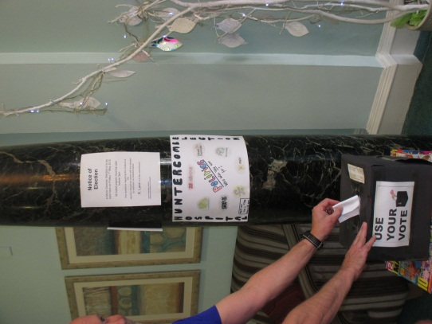

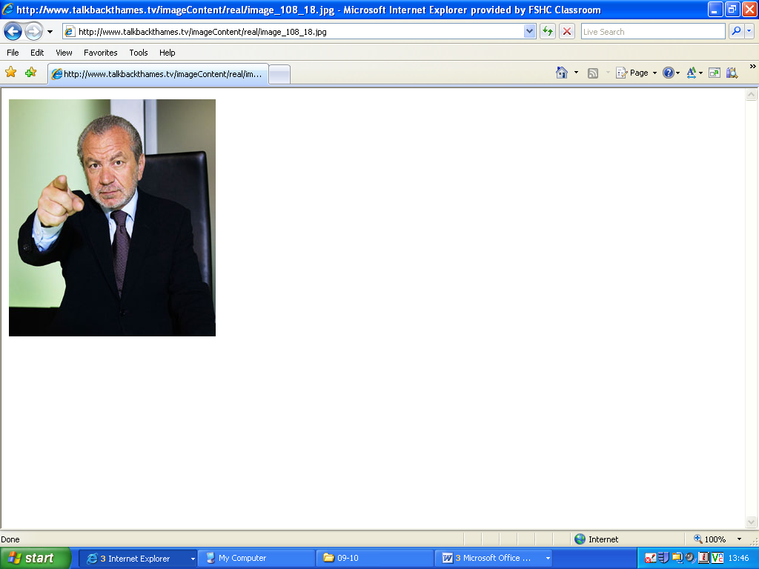

…………

You’re hired

…………

You’re fired

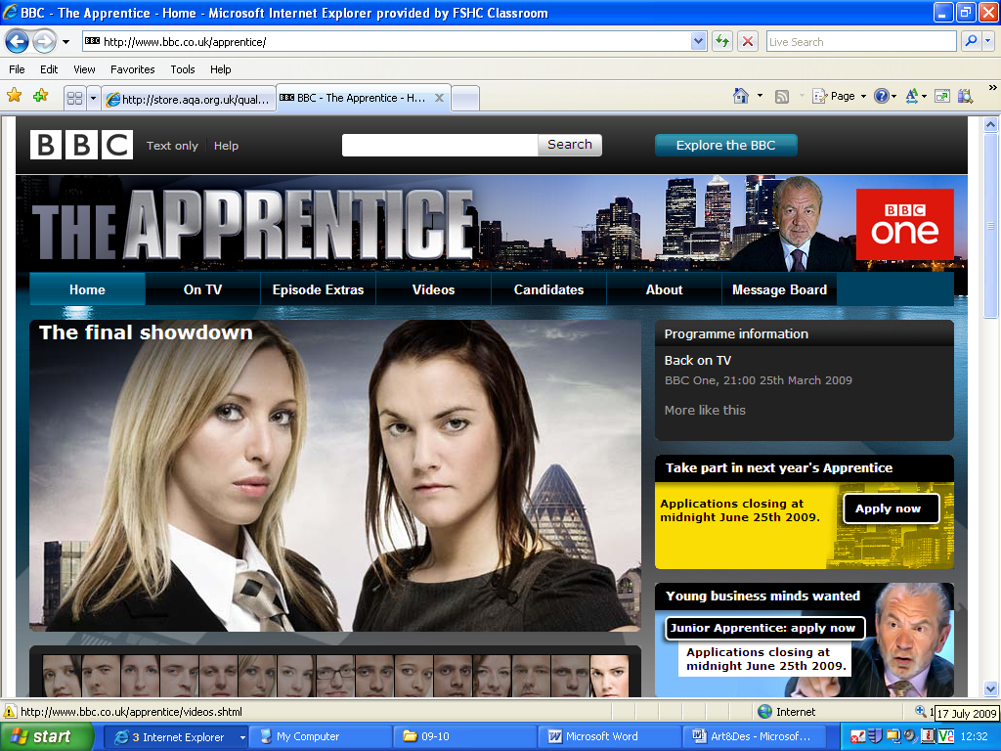

**YOU’RE FIRED**

**YOU’RE HIRED**

**Huntercombe Hospital School**

**Team challenge** – You‘re hired, You‘re fired, designing a new product – Chocolate Bar

Working in teams, students needed to look at strengths, who was best suited to what job. Task was to design and make a make the chocolate bar, design and produce packaging for the chocolate bar, create an advert, slogan and jingle. Students enjoyed working as part of a team and challenging themselves in areas they were not studying in their own school curriculm.

**Creative lessons**

Our creative sessions consist of Performing Arts, Music, Art & Technology

**Group task,designing and making the Huntercombe Wish Tree – displayed in reception with other work produced by patients.**

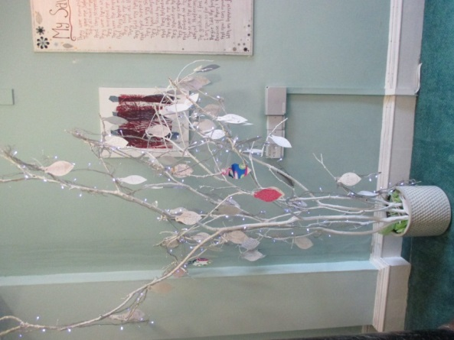

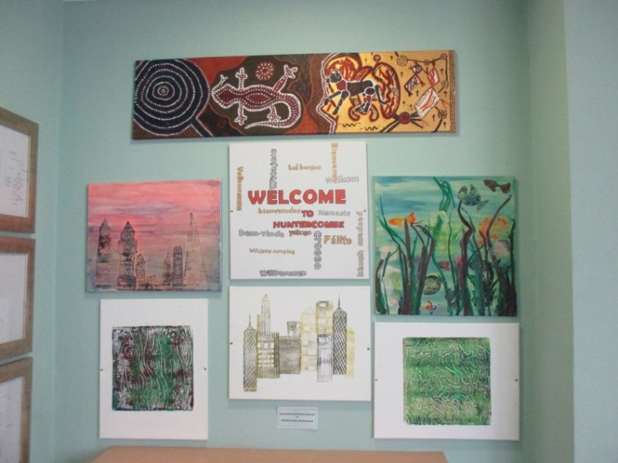

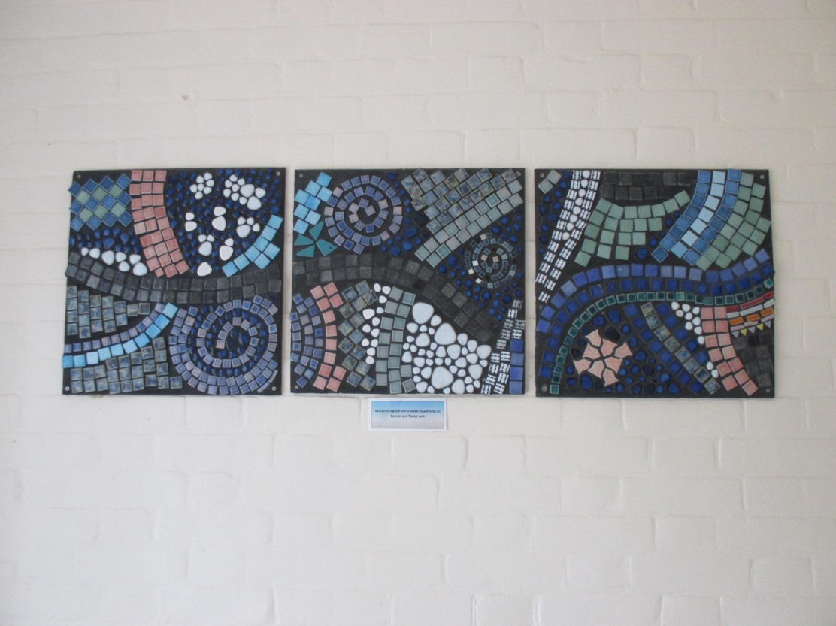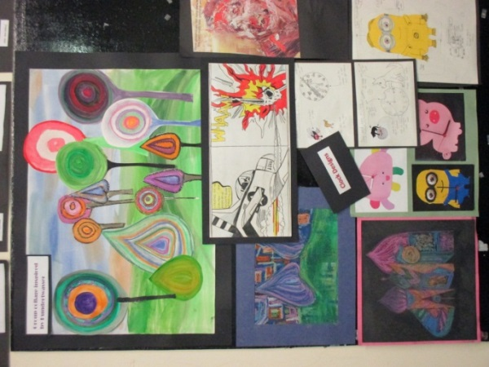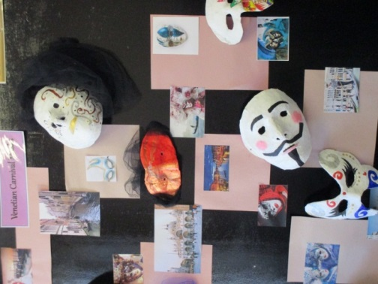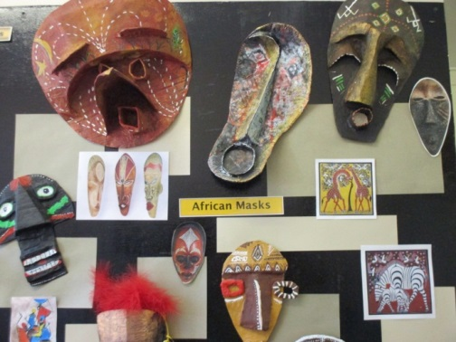

**Classroom - Art & Technology**

**Group designed and created mosiacs produced to be displayed in the entrance porch**

**Student Voice**



**The User Involvement Group**

User involvement groups are run monthly, two patient representatives from each unit attend. They will be the rest of the unit’s voice and bring suggestions/concerns to the meeting for discussion. This will be feedback to the school if anything involves education, the minutes are also taken to the monthly Information Governance Meeting.

Information from the User Involvement Group is also displayed on the unit notice boards in the form of “You Said” and “We Did” posters.

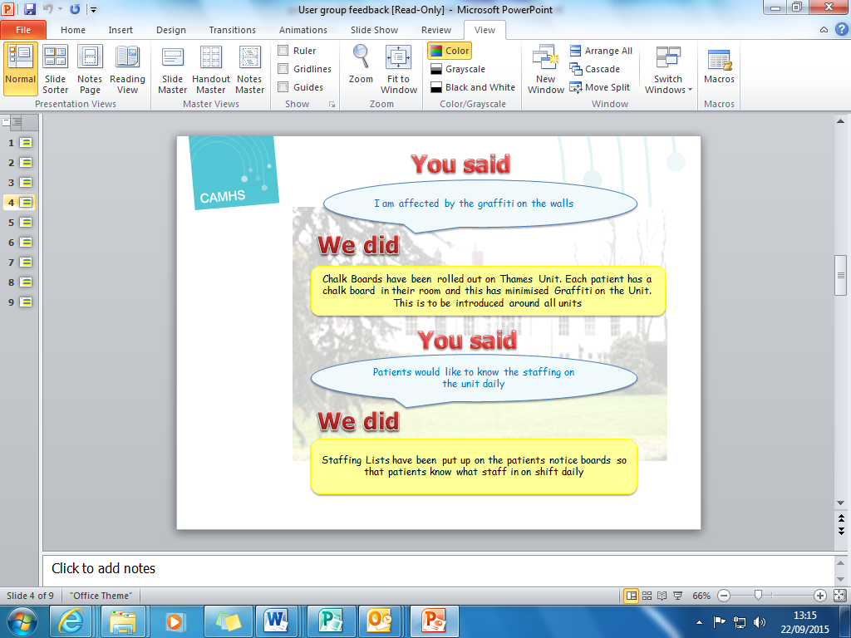**You Said – We Did**

**Student Questionnaires**

All students have the opportunity to complete a questionnaire every term, this focuses on them and on the teaching team. They also have an opportunity to say how they feel their education could improve.

Students can also speak about education in community meetings as well as speaking direct to the education team. The advocacy service POhWER visits fortnightly and any issues around school are feedback to the Education Manager to update.

**Additional Activities**

The school is residential as all students are in in-patient care. The Group Program of which school forms a part also involves:

* Sports – yoga, walking, games, swimming and classes off site when appropriate
* Activities – quizzes, games, crafts
* Trips – Zoo, country parks, museums, aquarium, pottery, cinema
* Therapeutic Groups
* School trips – these often include: Hampton Court Palace, Science Museum, The Natural History Museum, The V & A Museum, Tate Modern, Bird World, Chiltern Openair Museum, The Imperial War Museum
* End of Summer Term Celebration – Outdoor Movie Night

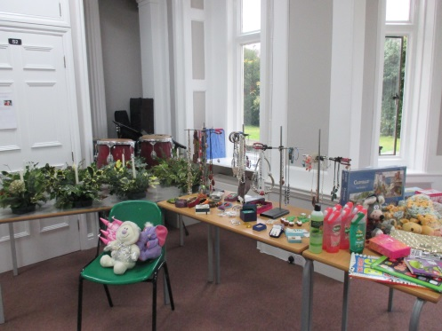



.

Christmas Fayre – money raised goes to charity



The shop at Hampton Court Palace is always popular!



Group project for Remembrance Day

Red Nose Day cakes

Macmillian Coffee morning students enjoy baking and staff always welcome the cakes

# Summer Fete

Every year we hold a Summer Fete, this occassion is a way of us raising money for local charities and having a fun afternoon. The fete is attended by staff, our patients & their families, past patients are also invited. Seeing past patients is often helpful to our patients and their families. Seeing how others have recovered and what they are achieving now, and we get the chance to find out what they are doing. Our afternoon starts with a barbeque lunch then entertainment from our talented young people whether in the form of singing or dance, then it is time to enjoy the afternoon visiting stalls and socialising. Our stalls include: tombolo, raffle, guess how many sweets in the jar, hook a duck, icecream van. Our young people will often be working on designing crocheted items, friendship bracelets, making cakes & biscuits, planning the beauty stall during some of their creative sessions on the unit. The day finishes with the traditional ‘Tug of War’ and a sports challenge between units to see who will hold the shield for the following year.

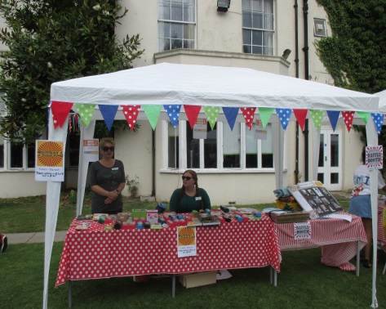

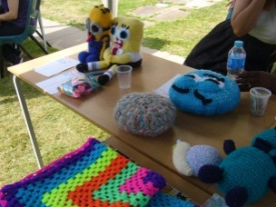

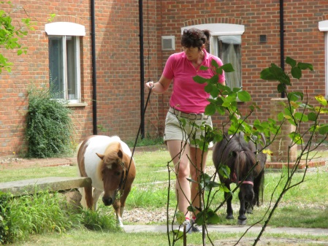

**Sports**

Every year we have a sports afternoon, all units are involved and we have something for everyone, as well as sprinting, relay Our PA system is set up to help get the excitement and astomsphere started. Patients who are not phsically able to take part often help with the scoring or will encourage others.

We always get involved with Sport Relief, for the last event students and staff took part in the ‘Run a Mile‘. When a major sporting activity is happening we always have our own version, Huntercombe World Cup, Huntercombe Olympics during these events staff from across the hospital will also get involved to show off some of their talents.

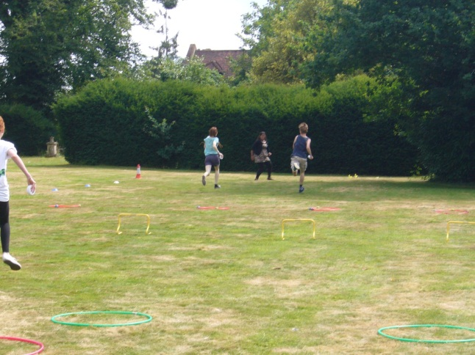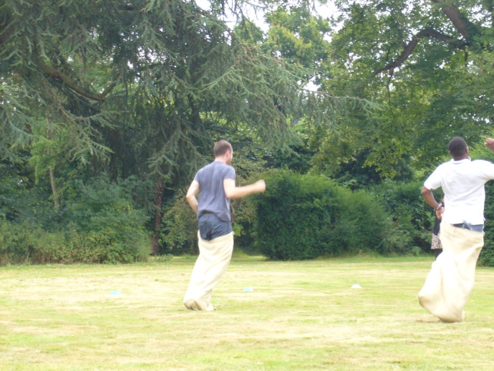

# T:\Photos\sports day\P1030723.JPG

Prizes are given out for the winning unit.

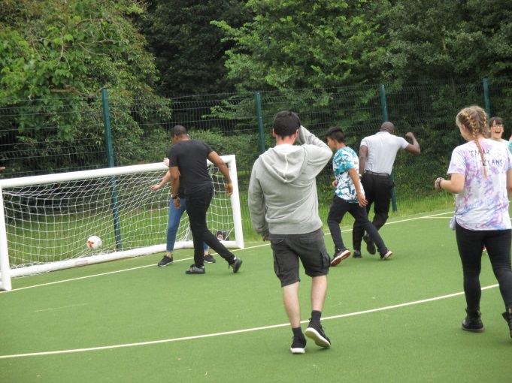P.E is on our timetable, this session is taught across all units with all age groups, as well as physical exercise this also offers a social aspect with students mixing with others from different units that they would not normally be taught with.